Arbitrary Arity Tree

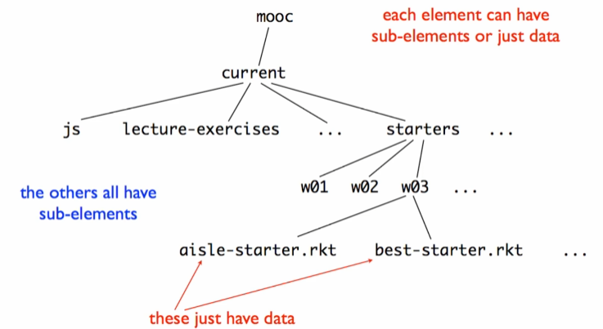

* Arbitrary sized in two dimensions

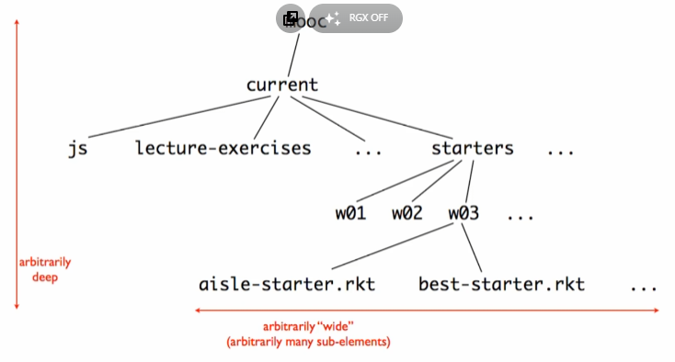

* Arbitrary means we just don’t know how big or small the size could be

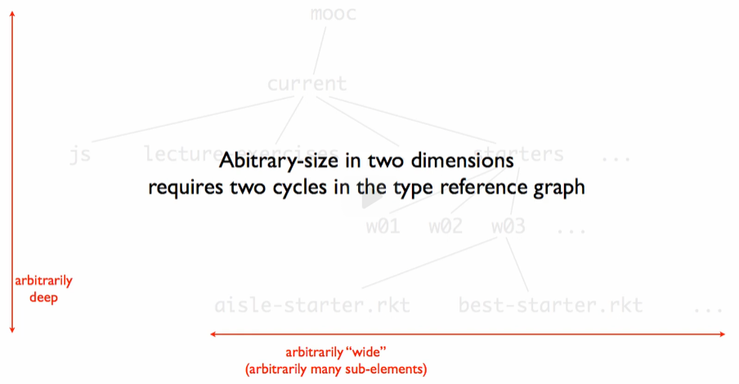

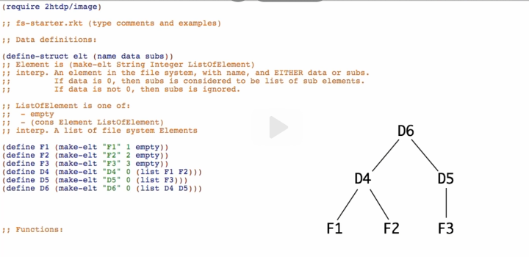

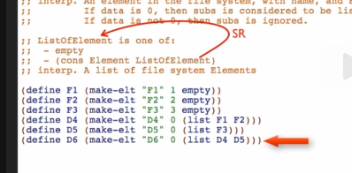

* Self-reference of ListOfElement is what allowing us to have arbitrary long list

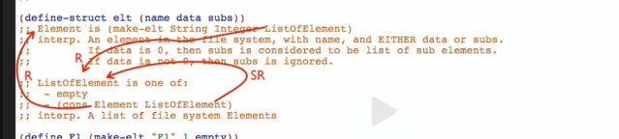

* But inside ListOfElement, there is a reference to Element
* And then inside Element, there is a reference back to ListOfElement

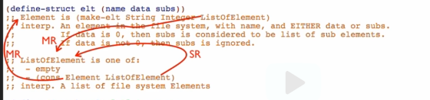

* We call this as ‘Mutual Reference’
* Because you can go from the definition of ListOfElement up to Element, and from the definition of Element back to ListOfElement

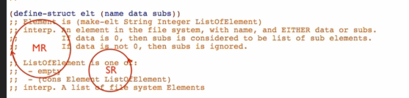

* We have MR cycle and SR cycle
  + SR Cycle (Self-Reference Cycle)
    - Allows each element to have an arbitrary amount of sub-elements, that is, allows the tree to have arbitrary breadth
  + MR Cycle (Mutual Reference Cycle)
    - Allows the tree to have arbitrary depth



* Breadth is for arbitrarily “wide”
* Depth is for arbitrarily “deep”

Drawing the arrows

